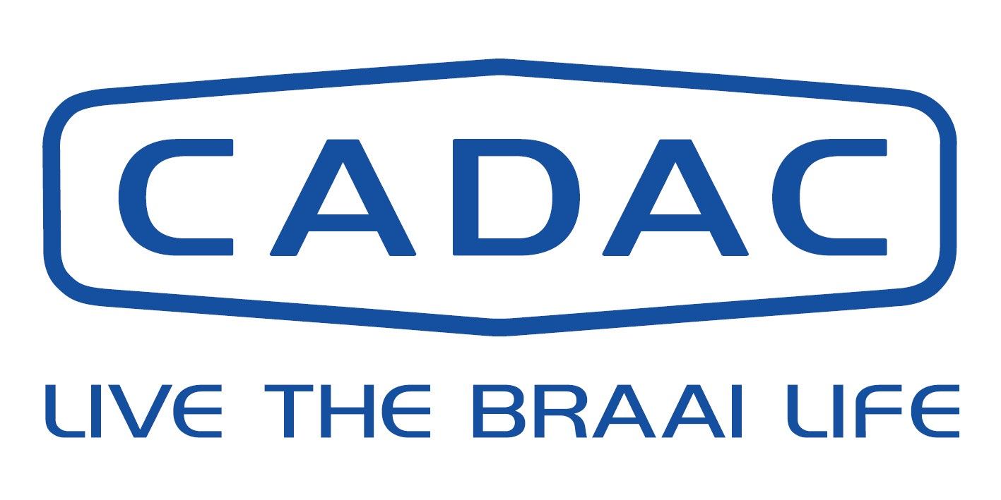 CONSUMER WARRANTY CLAIM FORM 2019
- Cadac Leisure Ltd t/a Cadac UK
- 1 Open Barn, Backridge Farm Business Centre, Twitter Lane, Bashall Eaves, BB7 3LQ.
(Please note this is the office address any returns sent here are considered unauthorised and will be refused.)
- If an inspection is deemed necessary, you will be advised of this in writing or by a member of staff
- For Cadac to deal with your warranty claim quickly and efficiently please could you complete and return to e-mail address: warranty@cadacuk.com or post to the above address
INFORMATION REQUIRED (please complete all boxed sections identified blue)
- DATE OF CLAIM:

- PRODUCT DESCRIPTION:

- PRODUCT (MODEL) CODE:

- SERIAL NUMBER:
(Leisure Serial Number located on a Silver Sticker which will begin SN: For Patio BBQ’s this is located inside of the cabinet doors)
- RETAILER NAME:

Hamilton Gas Products Ltd

- RETAILER REFERENCE:
- ADDRESS OR BRANCH PURCHASED:
2 Balloo Place, Balloo Industrial Estate, Bangor Co.Down BT19 7BP

- PLEASE CONFIRM IF THE CADAC PRODUCT WAS PURCHASED IN STORE OR DELIVERED DIRECT

£
- DATE OF PURCHASE: 10. PRICE PAID:

CUSTOMER

NAME:

ADDRESS:

E-MAIL: TELE NUMBER:
REASON FOR WARRANTY CLAIM:

Proposed Action by Cadac: To process your claim clear photos and proof of purchase must be attached with ALL claims Any authorised returns must be clean otherwise they will be returned without being inspected. E-MAIL: warranty@cadacuk.com TELE: (0333) 2000 363
Warranty No. Date of Action:

